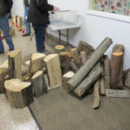  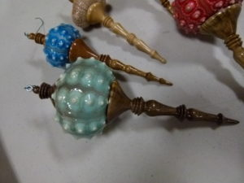  For more information contact:  Membership@CNEW.org  Two EASY ways to JOIN!  - Go to www.CNEW.org to fill out an application under “MEMBERSHIP” then “Join CNEW”  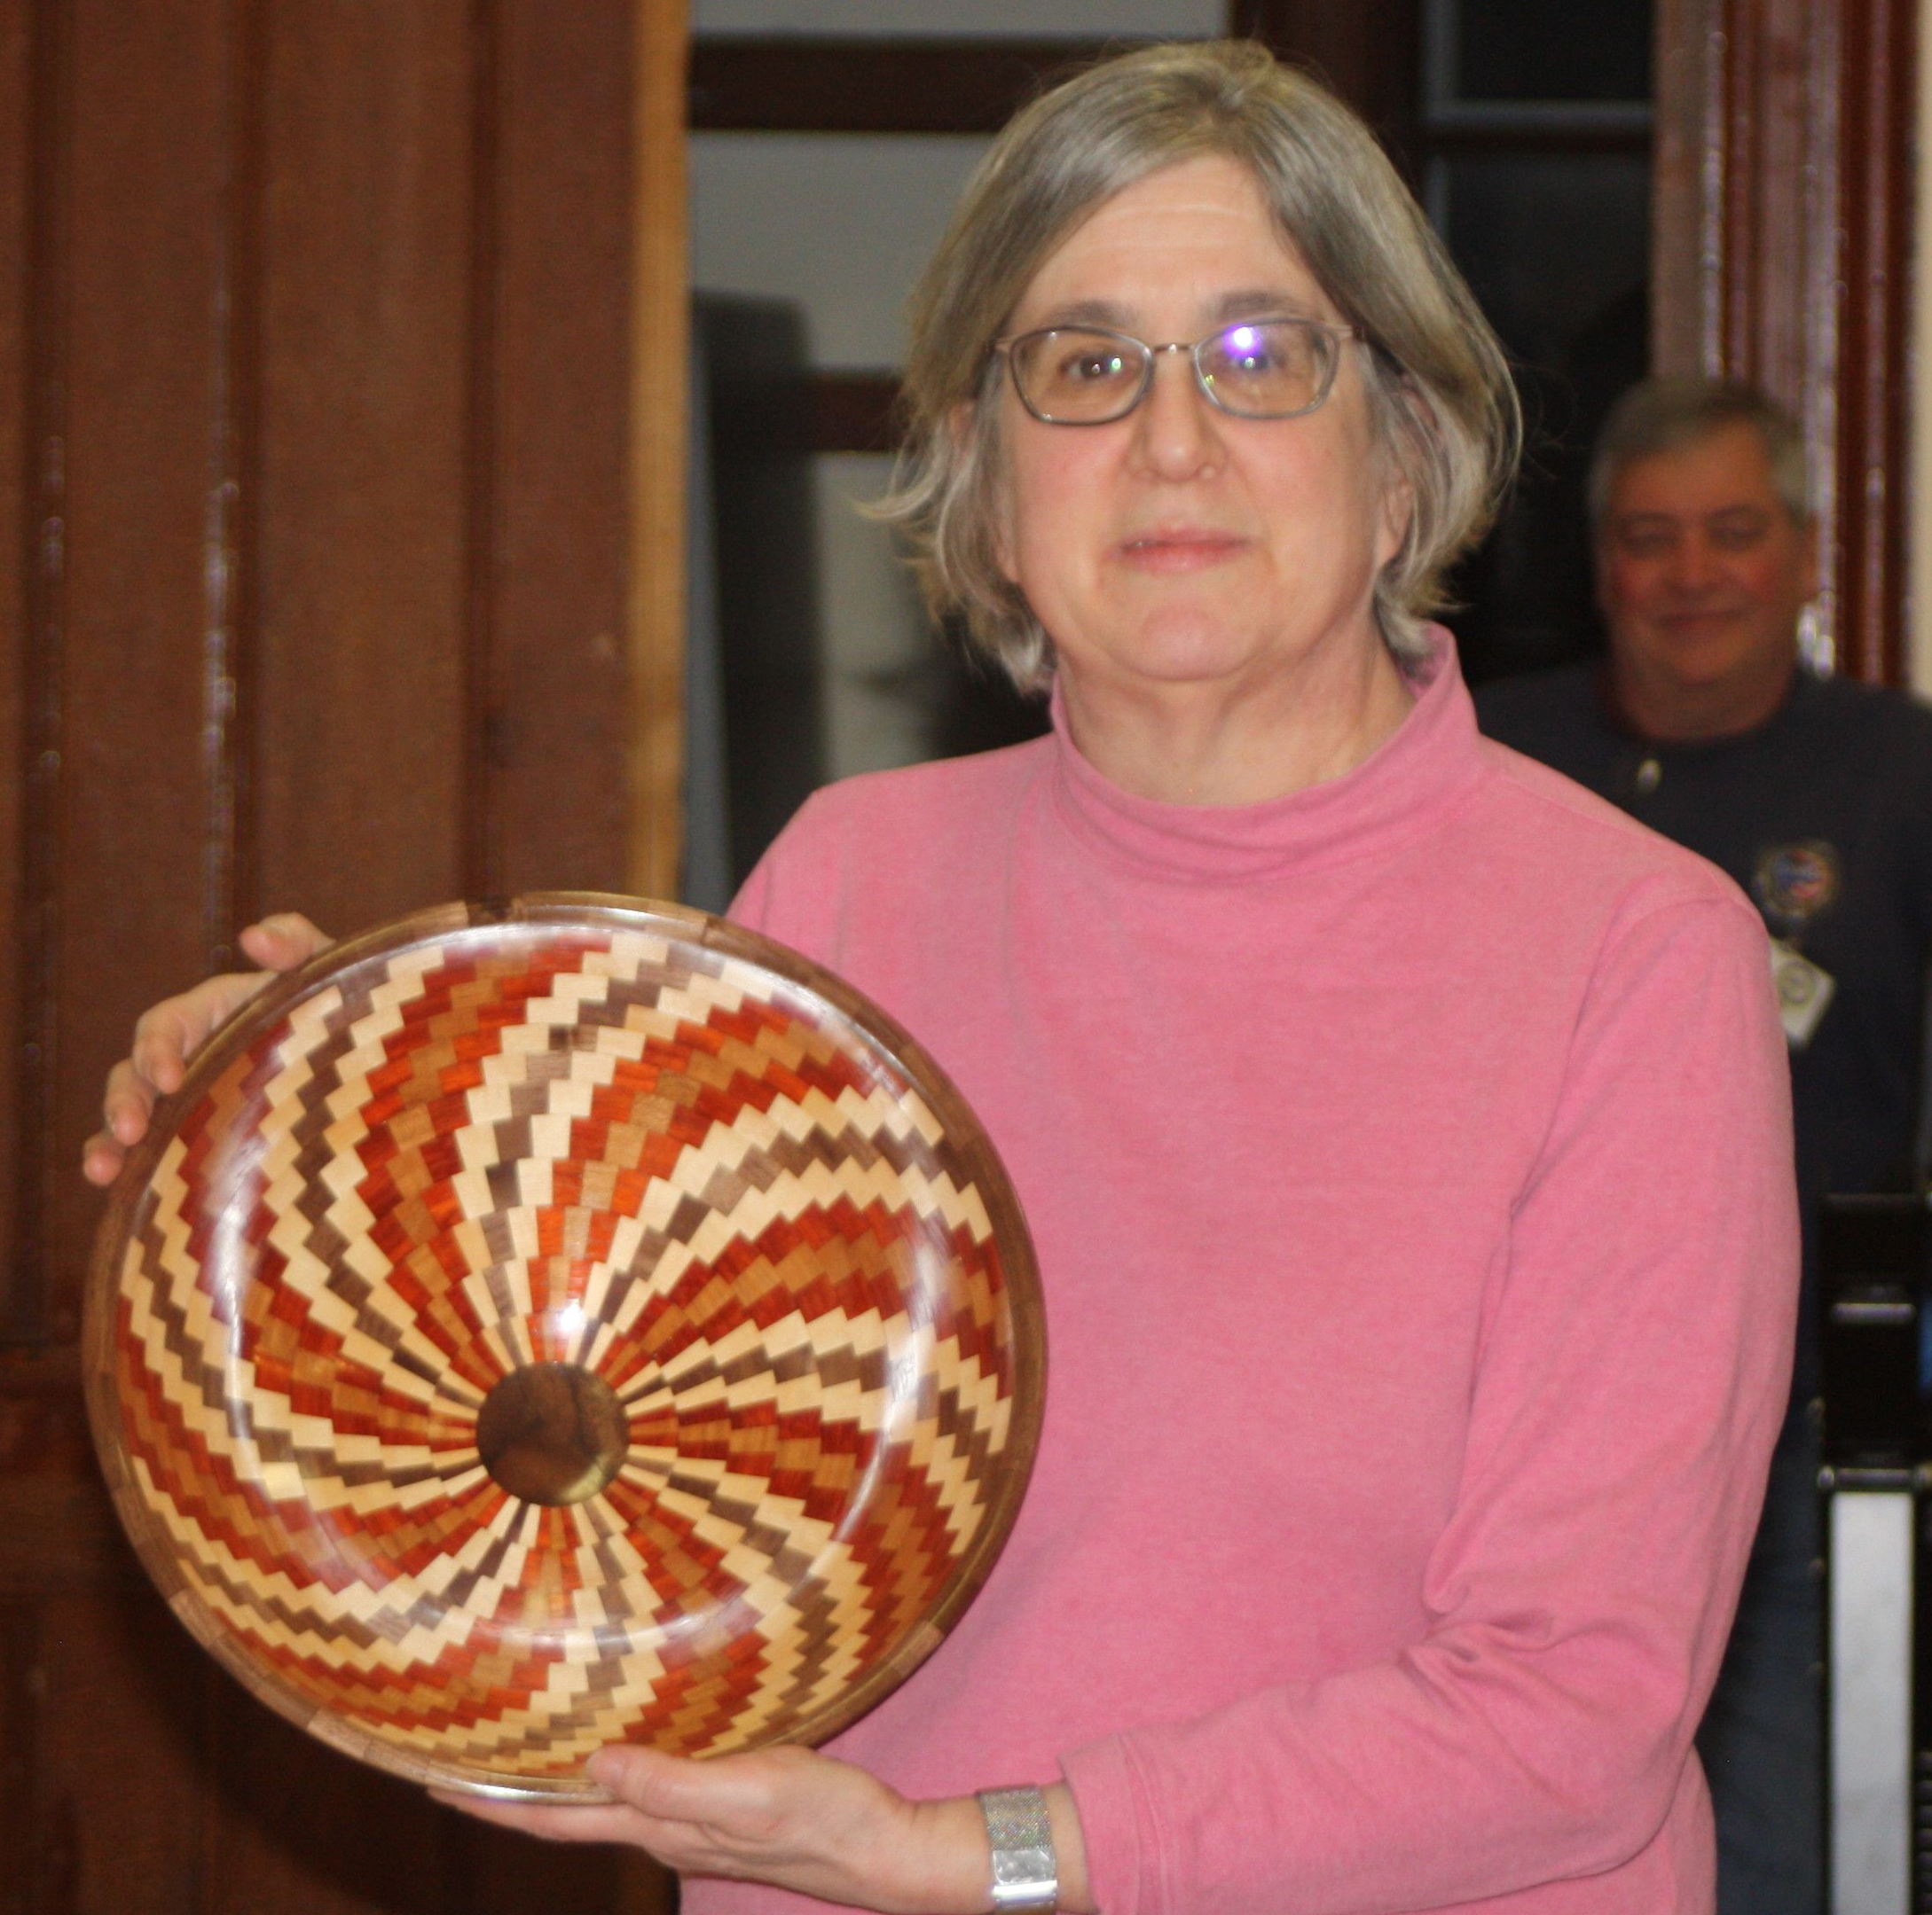  - Come to one of our Monthly Meetings!!  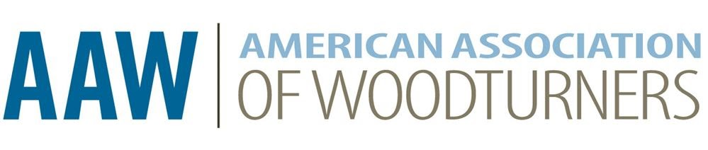 | Central New England Woodturners | Central  New England Woodturners  Central  New England Woodturners  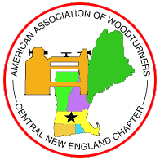  CNEW is a non-profit chapter of the American Association of Woodturners dedicated to the advancement of woodturning  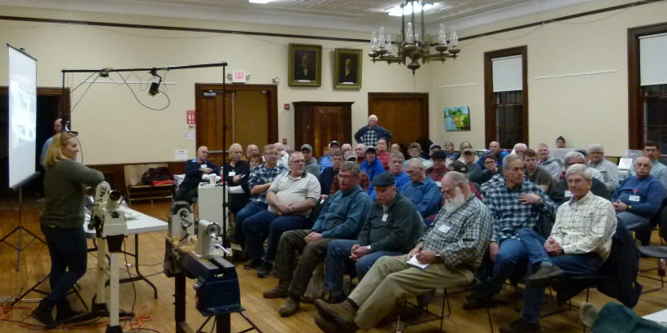  Our mission is to offer an organization for our members, to provide educational information, resources, camaraderie as well as social interaction with other turners  www.CNEW.org
The Central New England Woodturners is a local chapter of the American Association of Woodturners. Established in 1987, we were the first woodturning club in New England.  Our members’ skill levels range from those who have never turned before to master turners.  We all have one thing in common - our joy in creating useful and artistic pieces using a wood lathe.  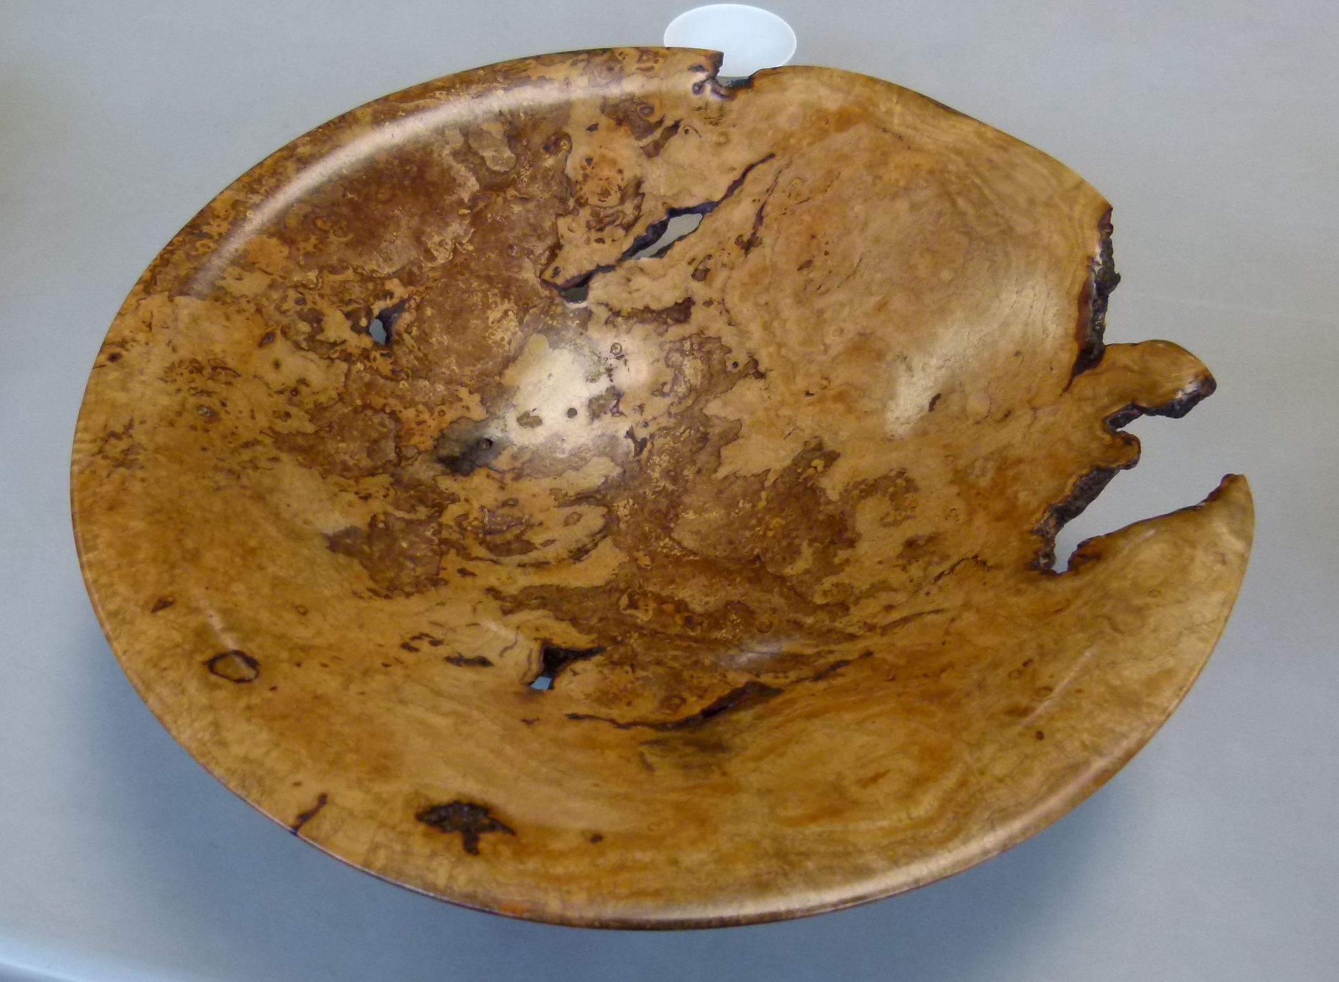  We always welcome visitors and new members to join our meetings on the First Thursday of every month at the 1870 Town Hall, 12 Woodward Ave, Berlin, MA 01503 at 6:30 PM.  Take your woodturning skills to the next level, and join us - you’ll learn from the best while sharing your experiences with others.  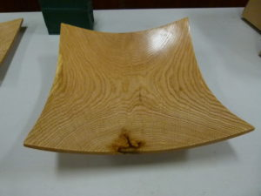  You will profit from the vast knowledge of our members in every aspect of woodturning whether it’s bowls, plates, spindles, pens, segmented, green wood, carving, or texturing.  Our members are always willing to share their experience to help other turners! |  | - CNEW SKEW – Stay up to date through our monthly newsletter. Keep informed of what is happening within the club as well as the woodturning community.  - Woodturning Demos – Each month we have demonstrations, conducted by club members and regionally known turners, on all manner of skills applicable to woodturning.  - Show & Tell – Members bring in their latest creations to share their trials, tribulations, and what they learned with everyone or to obtain feedback and advice.  - Member Library – Borrow a DVD from our club library. We have a lot of woodturning subject matter to choose from!  - Learn and Turn – Each month we conduct sessions where you can turn a small project on one of the club’s mini lathes, while being guided by a mentor.  - Wood Raffles – Members obtain wood from local sources and donate it to the club so that we can raffle it during our meetings.  - Supply Store – We “bulk-buy” woodturning consumables (i.e. sandpaper, CA glue, etc.) and pass the savings on to club members  - Special Discounts – Local and online retailers, such as Woodcraft, give members 10% discounts.  - Art & Craft Shows –We enjoy the opportunity to sell our works of art at club sponsored shows and regional events yearly.

Membership Benefits

Who are we?

